ASSIGNMENT 2

Subject Name: Exploratory Data Analysis Subject Code: BAI515E
Submitted By: Submitted To:
Nisarg M Rakkasagi
1AY24AI077 Ms. Surbhi

Table of Contents

Sl. No. | Topic | Page No.
1 | Introduction | 4
2 | Data Loading and Inspection | 4
3 | Pivot Table by Decade and Gender | 5
4 | Data Cleaning with Sigma-Clipping | 7
5 | Datetime Index and Weekday Analysis | 9
6 | Births by Day of the Year | 10
7 | Pivot Table versus groupby | 12
8 | Bonus: Lowest Birth Dates and Annotated Plot | 14
9 | Conclusion | 15
10 | References | 15

LIST OF FIGURES

SL.NO | TITLE | PAGE.NO
1 | Total births per year by gender | 7
2 | Mean daily births by day of week for each decade | 10
3 | Average daily births by calendar date | 12
4 | Average daily births with three holiday dips labelled | 15

LIST OF TABLES

SL.NO | TITLE | PAGE.NO
1 | Total births by decade and gender | 5
2 | Male-to-female ratio and percentage by which male births exceed female births | 6
3 | Mean daily births by day of week and decade | 9
4 | Decade-by-gender totals computed with groupby and unstack | 13
5 | Timing comparison of pivot_table and groupby + unstack | 13
6 | Five dates with the lowest mean births and matching holidays | 14

Introduction
Birth registrations are a good playground for exploratory analysis because they carry a calendar structure (year, month, day) and a categorical label (gender) next to a single count. In this assignment the CDC births file for the United States is examined with Python, Pandas and NumPy. The questions asked are simple but revealing: is one gender consistently born more often, how do daily counts change with the weekday and with the time of year, and what happens on public holidays? Along the way the report practises pivot tables, robust outlier removal with sigma-clipping, datetime indexing, and a comparison between pivot_table and groupby.
import numpy as np import pandas as pd
import matplotlib.pyplot as plt plt.rcParams['figure.dpi'] = 100
URL = 'https://raw.githubusercontent.com/jakevdp/data-CDCbirths/master/births.csv'

Task 1: Data Loading and Inspection
The first step is to pull the CSV directly from the repository link and look at it before doing anything else. Because later tasks need the file exactly as it was delivered, an untouched duplicate called bdf_raw is stored right after loading, and all cleaning is applied only to bdf. The inspection prints the top five rows, the number of rows and columns, the data type of each column and the count of empty cells per column.
bdf = pd.read_csv(URL) bdf_raw = bdf.copy() print(bdf.head()) print("Shape:", bdf.shape) print(bdf.dtypes)
print("Missing values per column:") print(bdf.isna().sum())

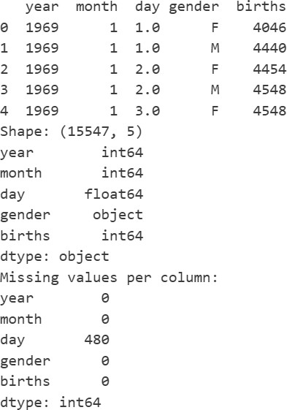
Output 1: First rows, shape, dtypes and missing-value counts

Why day is stored as a float
Output 1 shows that the file has 15,547 rows and that only the day column is float64, while year, month and births are integers. The reason is a limitation of NumPy: integer arrays have no representation for "missing", whereas NaN exists only as a floating-point value. The day column has 480 empty cells, because from 1989 the CDC published only the month of birth. Pandas therefore upgrades the whole column to float64, and an ordinary date such as the 5th is displayed as 5.0.

Task 2: Pivot Table by Decade and Gender
To group years into decades, each year is floored to a multiple of ten with 10 * (year // 10); for example 1987 maps to 1980. A pivot table then places decades down the rows and genders across the columns, adding up the births in each cell. Since this task is about totals over the entire file, it uses the uncleaned copy bdf_raw, which is also why the yearly plot below reaches 2008.

Do male births outnumber female births in every decade?
bdf_raw['decade'] = (bdf_raw['year'] // 10) * 10
by_decade = bdf_raw.pivot_table(values='births', index='decade',
columns='gender', aggfunc='sum')
print(by_decade)

print("Male > Female in every decade:", (by_decade['M'] > by_decade['F']).all())

Table 1: Total births by decade and gender
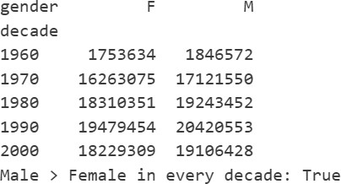

Comparing the M column with the F column row by row and calling .all() collapses the five comparisons into one answer, and that answer is True: boys outnumber girls in the 1960s, 1970s, 1980s, 1990s and 2000s alike. One caution is needed when reading the table. The file runs from 1969 to 2008, so the 1960 row holds a single year, the 2000 row holds nine years and the other rows hold ten. Totals of different rows are therefore not comparable with one another, but the male and female figures inside one row cover the same years and can be compared safely.

Male-to-female ratio and percentage excess
ratio_tbl = pd.DataFrame({
'M/F ratio': by_decade['M'] / by_decade['F'],
'% male excess': (by_decade['M'] / by_decade['F'] - 1) * 100
})
print(ratio_tbl.round(4))

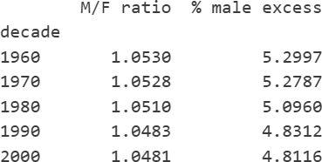
Table 2: Male-to-female ratio and percentage by which male births exceed female births

Dividing the male total by the female total gives the ratio, and subtracting one and multiplying by 100 converts it into a percentage excess. All five ratios lie between 1.048 and 1.053, so males exceed females by roughly 4.8% to 5.3%. There is a slight downward drift from the 1960s to the 2000s, but the level is remarkably steady. This is the well-documented human sex ratio at birth of about 105 boys per 100 girls, and it matches what Figure 1 suggests, for instance about 2.13 million boys against 2.03 million girls in 1990.

Total births per year by gender
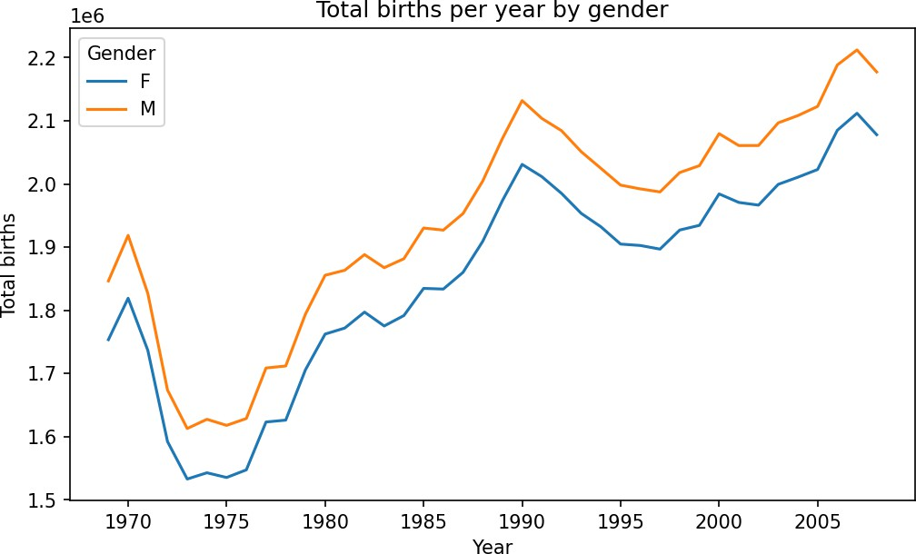
yr_tot = bdf_raw.pivot_table(values='births', index='year', columns='gender',
aggfunc='sum') ax = yr_tot.plot(figsize=(8, 4.5)) ax.set_xlabel('Year')
ax.set_ylabel('Total births') ax.set_title('Total births per year by gender') ax.legend(title='Gender')
plt.savefig('fig_births_per_year.png', dpi=150, bbox_inches='tight') plt.show()

print("Average yearly gap (M - F):", (yr_tot['M'] - yr_tot['F']).mean().round(0)) print("Average gap as % of female births:", ((yr_tot['M'] / yr_tot['F'] - 1) * 100).mean().round(2))

Figure 1: Total births per year by gender
The most striking feature of Figure 1 is that the two curves are almost parallel. Whatever drives the national birth count (the economy, family planning, the size of the parent generation) acts on boys and girls alike. Annual births fell steeply after 1970 and bottomed out in 1973 to 1975 at about 1.53 million girls and 1.61 million boys. They then recovered to a maximum around 1990, slipped until about 1997 and climbed again until 2007. Through all of this the male curve never dips below the female one, and the yearly difference of about 80,000 to 100,000 births stays near 5% of the female count, so the proportion is stable even though the absolute numbers move a lot.

Task 3: Data Cleaning with Sigma-Clipping
Not every row in the file represents a real day. Some rows carry impossible dates such as June 31, and others have no usable day at all (for instance the placeholder day 99). Such records show an abnormal births value: an impossible date collects only a few stray births, and a row without a day, which occurs from 1989 onward, behaves like a monthly total that dwarfs any single day. Since both kinds of rows sit far away from the normal daily range, a sigma-clipping rule applied to the births column can find them without inspecting dates one by one.

Quartiles, robust mean and robust standard deviation
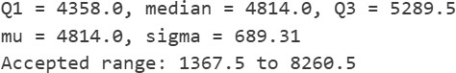
q1, q2, q3 = np.quantile(bdf['births'], [0.25, 0.50, 0.75]) center = q2
spread = 0.74 * (q3 - q1)
print(f"Q1 = {q1}, median = {q2}, Q3 = {q3}") print(f"mu = {center}, sigma = {spread:.2f}")
print(f"Accepted range: {center - 5*spread:.1f} to {center + 5*spread:.1f}")

Output 2: Quartiles, mu and sigma
Here the centre of the data is taken to be the median (4,814), and the spread is estimated from the interquartile range rather than from the usual standard deviation. The factor 0.74 has a short derivation. In a normal distribution with standard deviation s, the 25th and 75th percentiles sit about 0.6745 s on either side of the mean, so the IQR equals 1.349 s. Rearranging gives s = IQR / 1.349 = 0.7413 x IQR, which rounds to 0.74. The estimate of 689.31 therefore describes the spread of the typical rows, and the accepted band of 1,367.5 to 8,260.5 is wide enough to keep legitimate days while excluding the extreme ones.

Keeping rows within 5 sigma of mu
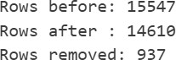
n_before = len(bdf)
bdf = bdf.query('(births > @center - 5 * @spread) & '
'(births < @center + 5 * @spread)').copy() print("Rows before:", n_before)
print("Rows after :", len(bdf))
print("Rows removed:", n_before - len(bdf))

Output 3: Number of rows before and after clipping
DataFrame.query() filters with a string expression, and a name prefixed with @ tells it to read a normal Python variable instead of a column. Only rows strictly inside the band survive. Of the 15,547 original rows, 14,610 remain, so 937 rows were discarded. This count includes the 480 rows with no day as well as the impossible-date rows.

Converting day to integers and why a robust estimate is used
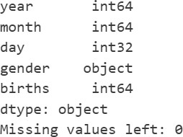
bdf['day'] = bdf['day'].astype(int) print(bdf.dtypes)
print("Missing values left:", bdf.isna().sum().sum())

Output 4: Column dtypes after the conversion
Applying astype(int) to the raw column would stop with an error, because NaN has no integer equivalent. After clipping, though, every row with a missing day is gone, no empty cell is left, and the conversion works. Output 4 shows the day column as an integer type (int32 in this run, where the exact width depends on the platform).
The decision to use the median and IQR instead of the mean and standard deviation is central to the method. Outliers affect the ordinary mean and standard deviation, the very quantities used to define what an outlier is: a few huge monthly totals would raise the mean, inflate the standard deviation and widen the acceptance band until some bad rows pass. Order statistics do not suffer from this. The median and the quartiles depend only on the position of values in the sorted list, so they stay put as long as fewer than about a quarter of the observations are corrupted. That makes the cut-off trustworthy.

Task 4: Datetime Index and Weekday Analysis

DatetimeIndex and day of week
With clean integer columns, pd.to_datetime can combine year, month and day into one timestamp per row, and the result is used as the index of the table. A DatetimeIndex exposes calendar attributes, so the day of the week (Monday is 0, Sunday is 6) is read from it and stored in a new column. The decade column is created once more, this time on the cleaned table, because the earlier one exists only on the raw copy.
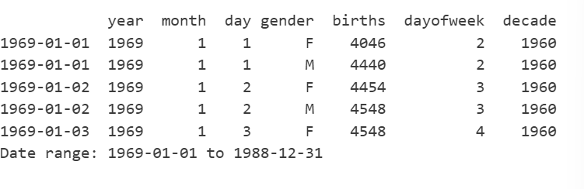
bdf.index = pd.to_datetime(bdf[['year', 'month', 'day']]) bdf['dayofweek'] = bdf.index.dayofweek
bdf['decade'] = (bdf['year'] // 10) * 10 print(bdf.head())
print("Date range:", bdf.index.min().date(), "to", bdf.index.max().date())

Output 5: Cleaned data with DatetimeIndex and dayofweek

Mean births by day of week and decade
wk_tab = bdf.pivot_table(values='births', index='dayofweek',
columns='decade', aggfunc='mean')
print(wk_tab.round(1))

ax = wk_tab.plot(figsize=(8, 4.5), marker='o') ax.set_xticks(range(7))
ax.set_xticklabels(['Mon', 'Tue', 'Wed', 'Thu', 'Fri', 'Sat', 'Sun']) ax.set_xlabel('Day of week')
ax.set_ylabel('Mean daily births')
ax.set_title('Mean daily births by day of week and decade') ax.legend(title='Decade')
plt.savefig('fig_births_by_weekday.png', dpi=150, bbox_inches='tight') plt.show()

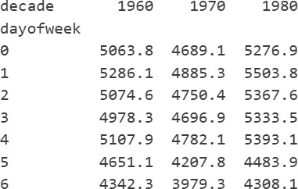
Table 3: Mean daily births by day of week and decade
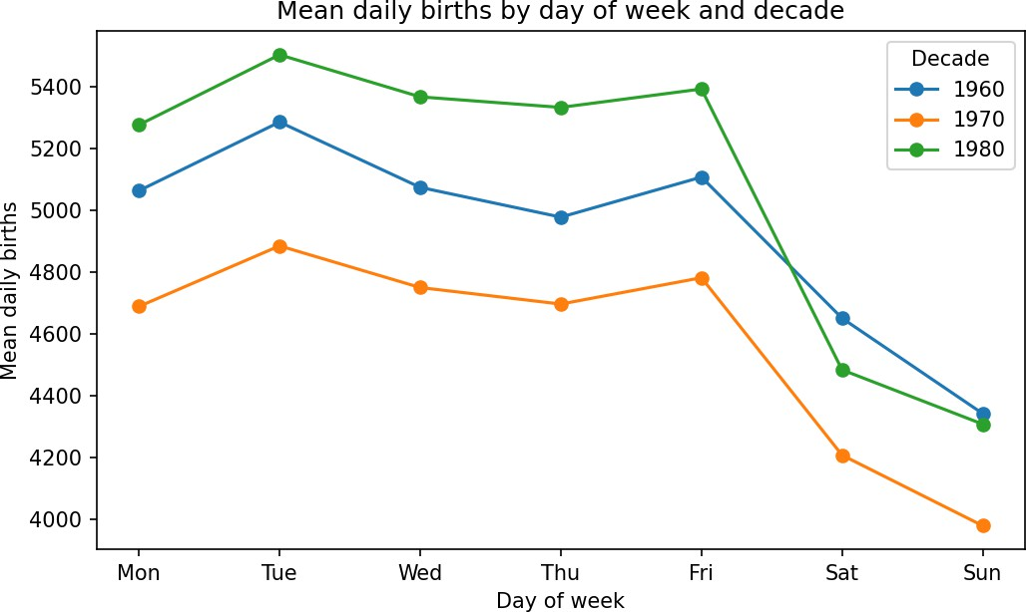

Figure 2: Mean daily births by day of week for each decade

Weekend dip and the missing decades
All three lines in Figure 2 have the same shape: a high plateau from Monday to Friday, a peak on Tuesday, and a sharp drop on Saturday and Sunday, with Sunday the lowest. In the 1980s, weekdays average roughly 5,300 to 5,500 births, while Saturday falls to about 4,500 and Sunday to about 4,300. If labour started at random, no weekday would be special. The pattern points to medical scheduling: caesarean sections and induced labours are arranged in advance and are mostly placed on working days, when hospitals have their full staff, so weekends receive fewer deliveries.
Only three decades appear in the figure although Figure 1 reaches 2008. The reason lies in the cleaning step. From 1989 the CDC file has no day value, and those rows hold whole-month counts that the 5-sigma filter rejected. After clipping, the table covers 1969 to 1988, so the decades present are 1960, 1970 and 1980; the 1960 curve is based on 1969 alone and the 1980 curve on 1980 to 1988.

Task 5: Births by Day of the Year

From a (month, day) multi-index to dates
The next question ignores the year completely and asks how an average day looks across the calendar. Pivoting with index=["month", "day"] averages births for each of the calendar dates over all years and both genders. To get a time axis, the two index levels are turned into ordinary columns, a constant year of 2012 is attached, and pd.to_datetime builds real dates from the three columns in one vectorised call.
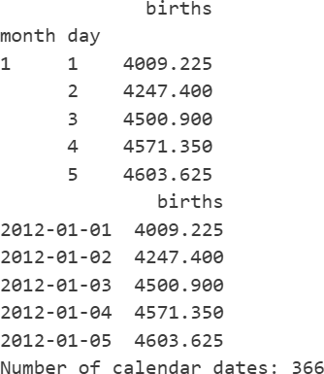
daily_avg = bdf.pivot_table(values='births', index=['month', 'day'],
aggfunc='mean')
print(daily_avg.head())

dates = daily_avg.index.to_frame(index=False) dates['year'] = 2012
daily_avg.index = pd.to_datetime(dates[['year', 'month', 'day']]) print(daily_avg.head())
print("Number of calendar dates:", len(daily_avg))

Output 6: Mean births by date before and after the date conversion
The dummy year must be a leap year. The data includes records for February 29, and a pair (2, 29) cannot be converted in a common year such as 2013, where pd.to_datetime would raise an error; deleting the row to avoid that error would silently lose a real date. Year 2012 contains all 366 possible dates, and the printed count of 366 confirms that none was lost.

Plot of mean births by date
fig, ax = plt.subplots(figsize=(12, 4)) daily_avg.plot(ax=ax, legend=False) ax.set_xlabel('Date (dummy year 2012)') ax.set_ylabel('Mean daily births') ax.set_title('Average daily births by calendar date')
plt.savefig('fig_births_by_date.png', dpi=150, bbox_inches='tight') plt.show()

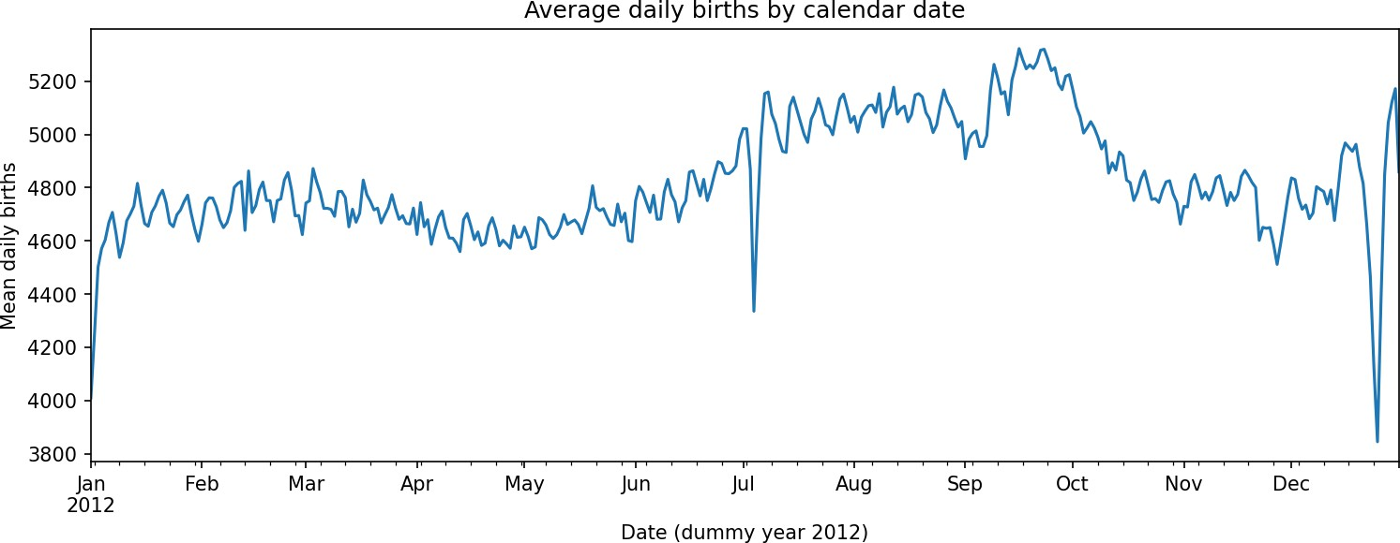
Figure 3: Average daily births by calendar date

Holiday dips
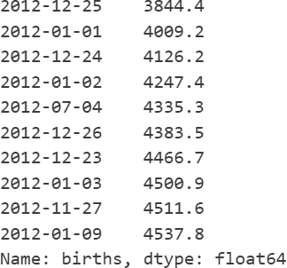
print(daily_avg['births'].nsmallest(10).round(1))

Output 7: Ten calendar dates with the lowest mean births
A yearly profile of this kind has a slow seasonal component and a few sharp spikes downward. The slow part is a rise from July to a mid-September maximum, which is not tied to a holiday. The spikes are New Year's Day (about 4,000 births against a typical winter figure near 4,700), Independence Day (about 4,330) and, deepest of all, Christmas Day (about 3,850). The adjacent days, such as Christmas Eve and January 2, are also depressed. Holidays that move, such as Thanksgiving on the fourth Thursday of November and Labor Day on the first Monday of September, land on different calendar dates in different years, so averaging by date smears them into weaker, broader dips.
Nature cannot explain a drop on specific dates, because a baby is no less likely to arrive on December 25. The explanation is human scheduling: planned caesareans and inductions are rarely booked on holidays when staff are away, and they are often moved to the days before or after. This is the same mechanism that produced the weekend dip in Task 4.

Task 6: Pivot Table versus groupby

The decade-by-gender table using groupby
gb_tab = bdf_raw.groupby(['decade', 'gender'])['births'].sum().unstack() print(gb_tab)
print("Identical to pivot table:", gb_tab.equals(by_decade)) pd.testing.assert_frame_equal(gb_tab, by_decade, check_names=False)

Table 4: Decade-by-gender totals computed with groupby and unstack
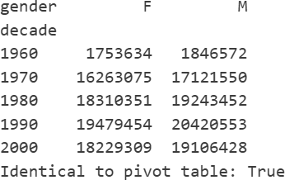

The same table can be produced in two steps. Grouping by decade and gender and summing the births yields a Series with a two-level index, and unstack() rotates the inner level (gender) into columns. Both the boolean test equals() and the stricter assert_frame_equal() confirm that this table matches the pivot table of Table 1 exactly. Both were computed from bdf_raw, so the comparison is made on identical input.

Timing the two approaches
t_pivot = %timeit -o bdf_raw.pivot_table('births', index='decade',
columns='gender', aggfunc='sum') t_group = %timeit -o bdf_raw.groupby(['decade',
'gender'])['births'].sum().unstack()

timing = pd.DataFrame({
'Method': ['pivot_table', 'groupby + unstack'],
'Mean time (ms)': [t_pivot.average * 1000, t_group.average * 1000], 'Std dev (ms)': [t_pivot.stdev * 1000, t_group.stdev * 1000],
}).round(3)
timing['Relative speed'] = (timing['Mean time (ms)'] / timing['Mean time (ms)'].min()).round(2) print(timing.to_string(index=False))

Output 8: %timeit results

Table 5: Timing comparison of pivot_table and groupby + unstack

Method | Mean time (ms) | Std dev (ms) | Relative speed
pivot_table | 5.899 | 0.839 | 2.11
groupby + unstack | 2.795 | 0.532 | 1.00

How a pivot table relates to groupby
Internally a pivot table is a groupby followed by a reshape. Both approaches split the data into groups by the key columns, aggregate each group, and assemble the outcome; pivot_table simply performs the unstacking itself so that one key ends up as the column header. With identical keys and the same aggregation (sum), the output cannot differ, which is why Tables 1 and 4 match.
What differs is the interface and the cost. pivot_table is a compact, spreadsheet-like call with extras such as margins and fill_value, while groupby is the more general tool: it can aggregate without any reshaping, apply several functions, or transform groups. Those extras give pivot_table extra work to do. The timing test reflects this, with pivot_table averaging 5.9 ms against 2.8 ms for groupby + unstack, so it was about 2.1 times slower here. For a table this small the absolute difference is negligible, but it can matter on much larger data.

Bonus: Lowest Birth Dates and Annotated Plot
hol_map = {(1, 1): "New Year's Day", (1, 2): "Day after New Year's",
(7, 4): "Independence Day", (12, 25): "Christmas Day",
(12, 24): "Christmas Eve", (12, 31): "New Year's Eve",
(11, 11): "Veterans Day", (2, 29): "Leap day (few samples)"}

bottom5 = daily_avg['births'].nsmallest(5).to_frame('mean births').round(1) bottom5['holiday'] = [hol_map.get((d.month, d.day), 'no fixed-date holiday')
for d in bottom5.index]
print(bottom5)

fig, ax = plt.subplots(figsize=(12, 4.5)) daily_avg.plot(ax=ax, legend=False)
for (m, d), name, offset in [((1, 1), "New Year's Day", (25, -25)),
((7, 4), "Independence Day", (0, -40)),
((12, 25), "Christmas Day", (-60, -30))]:
ts = pd.Timestamp(2012, m, d)
ax.annotate(name, xy=(ts, daily_avg.loc[ts, 'births']), xytext=offset, textcoords='offset points', arrowprops=dict(arrowstyle='->'), ha='center')
ax.set_xlabel('Date (dummy year 2012)') ax.set_ylabel('Mean daily births')
ax.set_title('Average daily births with holiday dips labelled') plt.savefig('fig_births_annotated.png', dpi=150, bbox_inches='tight') plt.show()

Table 6: Five dates with the lowest mean births and matching holidays

Rank | Date | Mean births | Matching holiday
1 | December 25 | 3844.4 | Christmas Day
2 | January 1 | 4009.2 | New Year's Day
3 | December 24 | 4126.2 | Christmas Eve
4 | January 2 | 4247.4 | Day after New Year's
5 | July 4 | 4335.3 | Independence Day

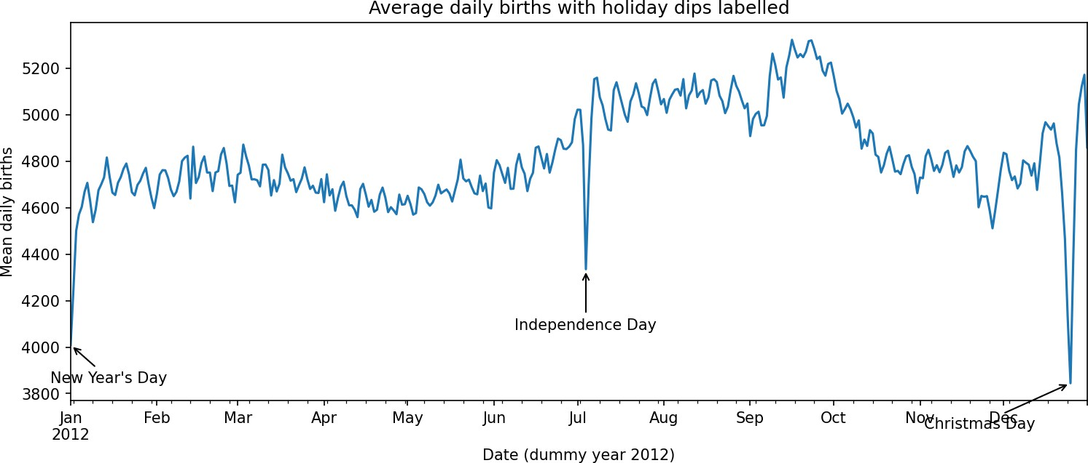
Figure 4: Average daily births with three holiday dips labelled
The five quietest dates, in order, are Christmas Day (about 3,844 births), New Year's Day (4,009), Christmas Eve (4,126), January 2 (4,247) and Independence Day (4,335), and every one of them is a holiday or sits right next to one. Figure 4 marks the three that are deepest and most clearly isolated, namely Christmas Day, New Year's Day and Independence Day, with arrows. That all of the lowest values coincide with holidays supports the explanation from Task 5 that fewer deliveries are scheduled on those days.

Conclusion
Three main findings come out of this study. First, boys are born more often than girls in every decade, by about 5%, and the ratio hardly changes over forty years. Second, birth counts are not uniform in time: they are clearly lower on Saturdays, Sundays and public holidays, a pattern that is best explained by planned medical procedures and not by biology. Third, on the technical side, a median and IQR based sigma-clip removed the corrupted rows reliably, which allowed an integer day column and a proper datetime index, and the pivot_table and groupby + unstack routes were shown to give the same table, with groupby being the faster of the two in the timing test and pivot_table the more convenient to write.

References
- VanderPlas, J. CDC Births Dataset.
- Pandas Development Team. Pandas Documentation: Pivot Tables.
- Matplotlib Development Team. Matplotlib Documentation.

